*Annex B: Accomplishment Report Template for Technical and Admin Staff (RO,PO, Cluster)*

**Individual Daily Accomplishment Report**

Date: April 07, 2020

Name:  **Christian Paul V. Ferrer**

Position: **Network Administrator**

Station/ Office/ Division/Section: **FAD-RICTU**

|  |  |  |
| --- | --- | --- |
| **ACTIVITIES** | **ACTION TAKEN** | **REMARKS** |
| Continuous development of the "Financial and Administrative System (FAS)". | Continued revision of Supplier’s Quotation that can add multiple quotations in one user interface. |  |

Submitted by: Noted by:

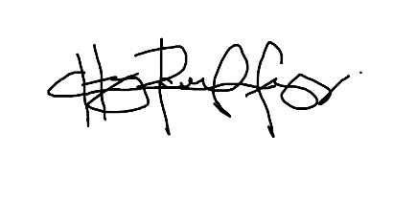

**CHRISTIAN PAUL V. FERRER** **MAYBELLINE M. MONTEIRO**

Network Administrator Chief, FAD-RICTU